**Name:** __________________________________________________________ 1stgrade

* Imprimir solo si **NO** tienes el libro en casa

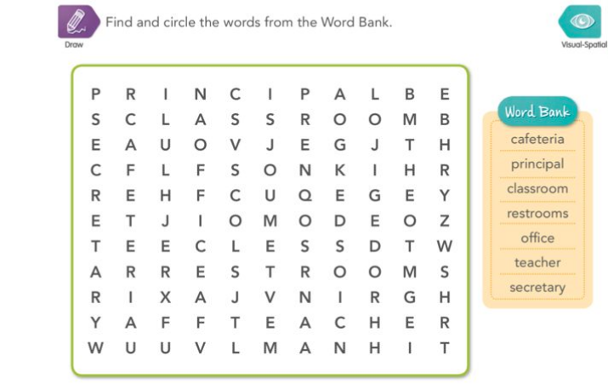

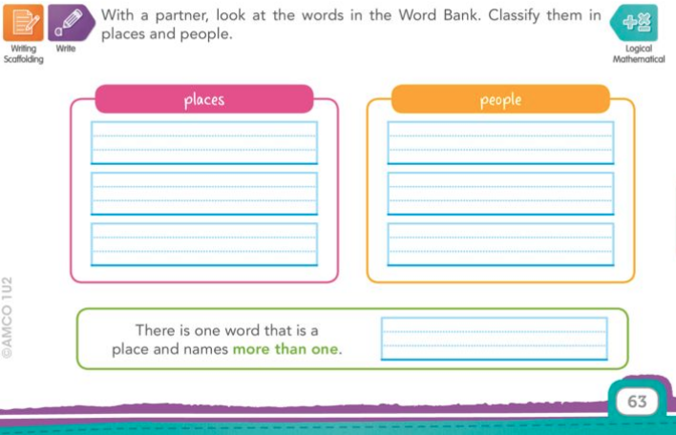

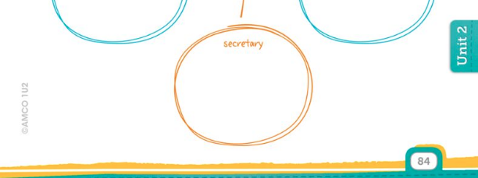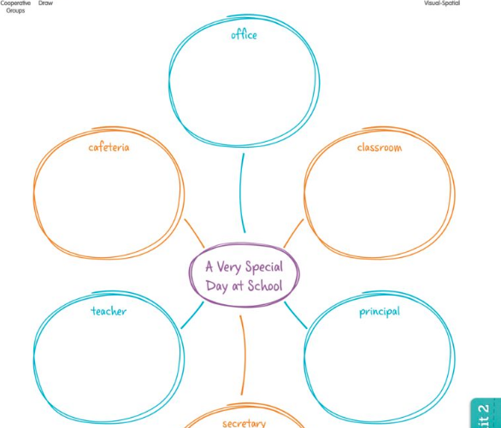Macintosh HD:Users:Giovi:Desktop:Captura de pantalla 2020-05-28 a las 20.45.45.png

Complete the mind map. Make drawings and write words.