

Look at the part of the body to identify the sense. Draw and color something related to that. Cut all the pieces by the lines, then play matching the sense with the corresponding image.

z

**I HEAR**

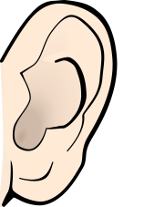

**with my ears.**

**I SMELL**

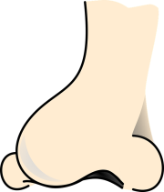

**with my nose.**

**I SEE**

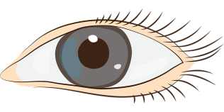

**with my eyes.**

**I TOUCH**

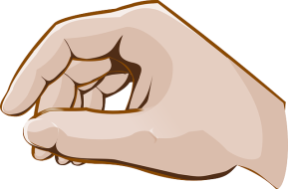

**with my hands.**



**with my tongue.**

**I TASTE**