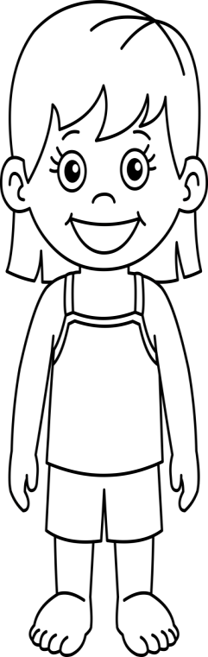

My Body Parts Book

By:

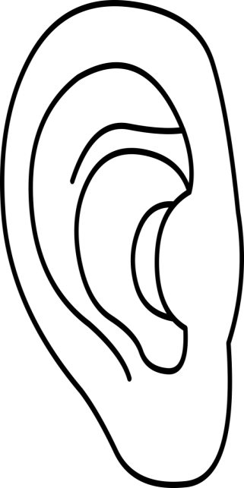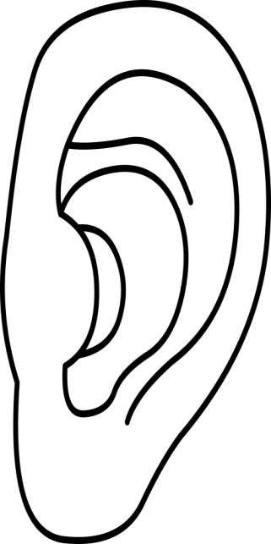

I have ears. My ears help me to hear. These are my ears.

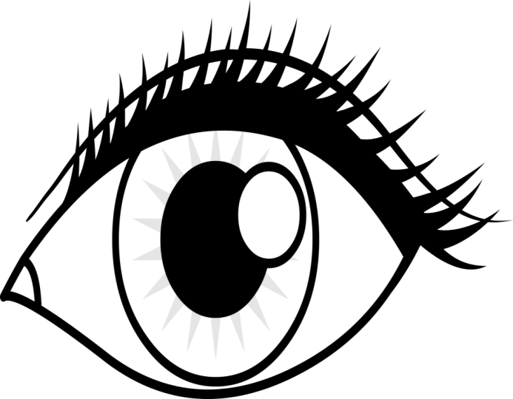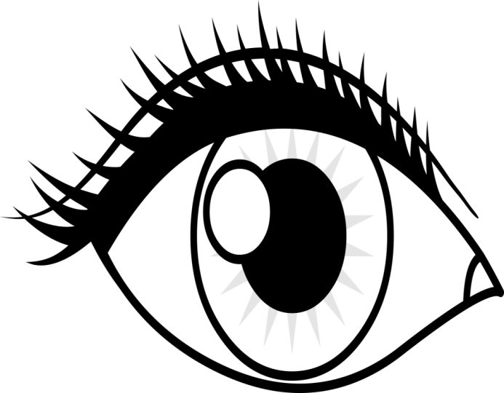

I have eyes. My eyes help me to see. These are my eyes.

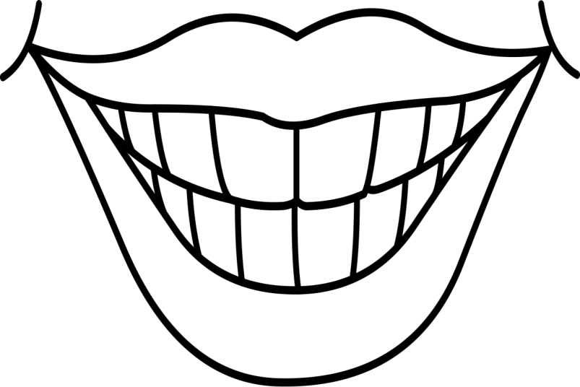

I have a mouth. My mouth has teeth. They help me to eat. This is my mouth and my teeth.

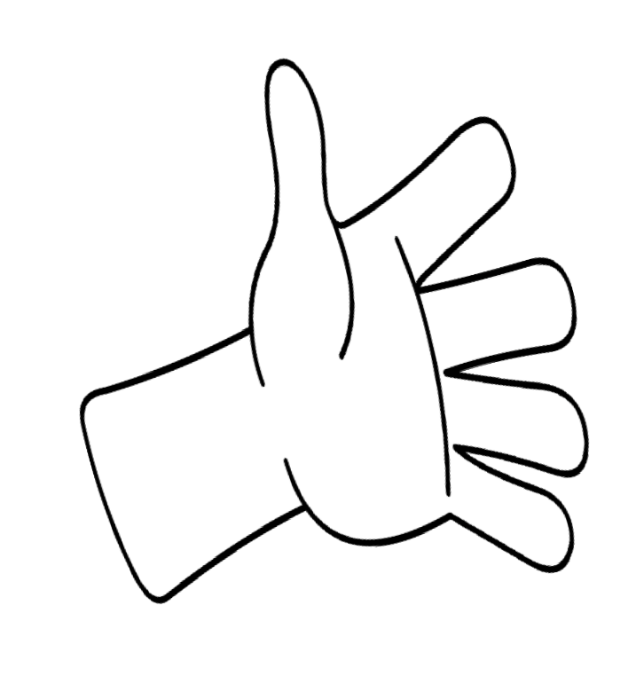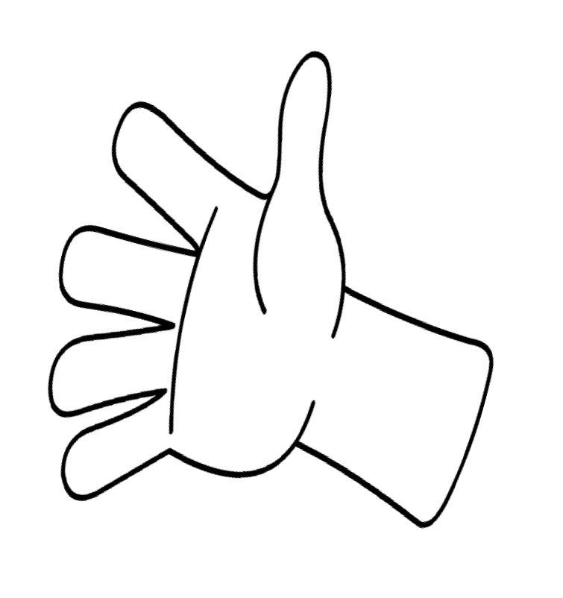

I have hands. My hands have finger. They help me to feel. These are my hands and fingers.

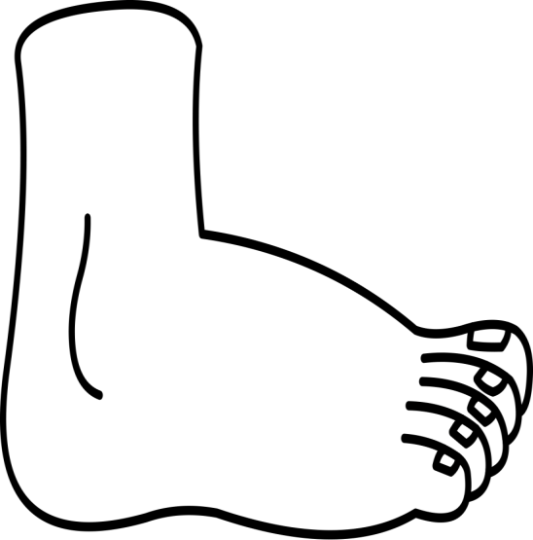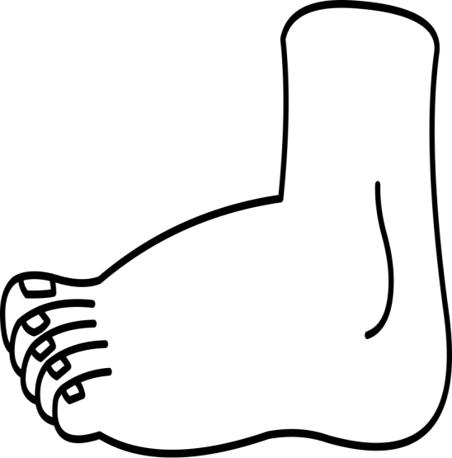

I have feet. My feet have toes. They help me to run and stomp. These are my feet and toes.

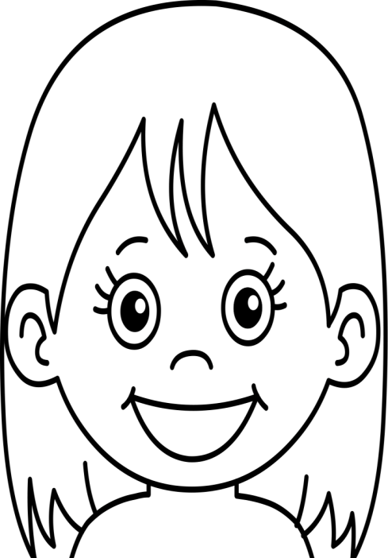

I have a head. My head helps me think. This is my head.

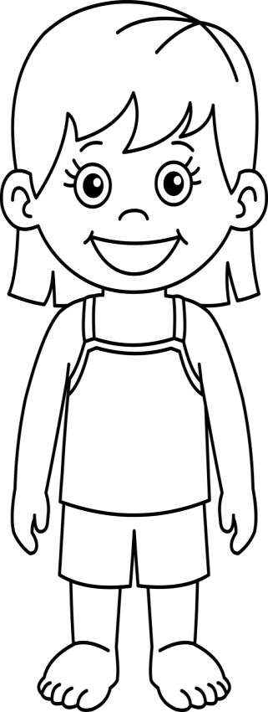

This is me!

I love myself!

I have a nose. My nose helps me to smell.

Draw your nose

I have legs and knees. My legs and knees help me to move.

Draw your legs and knees

I have legs and knees. My legs and knees help me to move.

Draw your legs and knees