GUÍA CLASE ONLINE
‘MY FAVORITE ANIMAL’

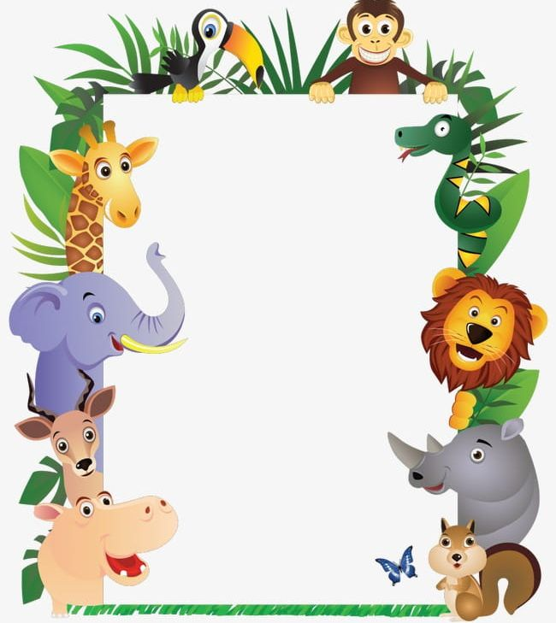
Draw inside the box your favorite animal.

