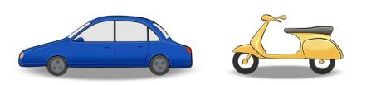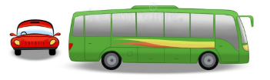TRANSPORTS



AIR

SEA

LAND

Online class activity

|  |
| --- |
| https://lh3.googleusercontent.com/KFY12xSNKRH0q7YPfjCqntiZwEgk9IJnO_Z9sz06KLpvoGjcvu8mwI82QIcBbNpla76ka30KXjtQciSlvBhABtc-1O6fMu6kUiNKJRuq66svur3e4PAQuGw4GGkMw2GKESTMF8Uu |

|  |
| --- |
| https://lh3.googleusercontent.com/UwFBwkqide5_IMWSbiK6eq30jFBGShTTeYFYPc9Y4iQI_muzoPNck8tj3b1AD-ehHtGxCsYjXAMPYXvyJIPAjoihI4JyM8NDT8KCeJ77FE2b2LD-2DOU3avXBfS43kGIhDrMDw9H |

|  |
| --- |
| https://lh6.googleusercontent.com/F3I0WBKhy_SaYMD3B1Xc_rFg_skvi8g3KQ88W8YG-UHXDhQmiqmkSxK8t574RgZn83p_jywNjOWZsdsotr-gSsqGZiwz_5tWn76D3MHxzTDYnhTF-NGAlOzuIRaLL12nTrsQudVC |

|  |
| --- |
| https://lh6.googleusercontent.com/hGfmoJ4sRRSQWGZoZc-KYRV5UiPjoBiP-Hc1DpBvG6anHOFynv8i99YvHZ4cIRjYw-6wKCdkWjAXzcSOQH-eny_-FcbLGUhju6-cj_F69mJI99EFRCwhwqzEzHidG_LNIt2R_-88 |

|  |
| --- |
| https://lh5.googleusercontent.com/9iZGZaDj1H4nsRMIDklw57Xv0k_-E7HLZYaSreqH29PP_iA9Qmz6zqs0Q_oR6nR-RC4wG9qiREBjXoNEgiVkyU2qL83GnL685yDN_yJJuMz0BP8L6tEfmE7fny-e12cL3egAE-65 |

|  |
| --- |
| https://lh4.googleusercontent.com/fDXw5CLMwXBztkZT8DcPAsA-_afN7oDoJQzJLVyNE17L2HBI-Py0Vhp7d6-LBjaWrK_veMovYwxY88dwLaEwR3TwpFWTPNb_YSb6qo3tuQHr_ujr3SVs70PiK6WuvnwllPqAXEKu |