**DESCRIPTIVE WORDS**

**Name:** __________________________________________________________ 1stgrade

Look at the monsters and circle the correct answer.

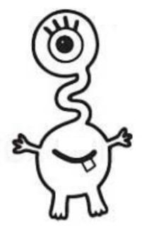

***EXAMPLE:***

IT IS **LUCY**

* It is SHORT – TALL
* It has 1 - 2 - 3 - 4 - 5 EYES
* It has 2 SHORT – LONG ARMS
* It has 2 SHORT – LONG LEGS

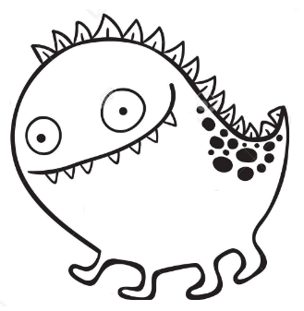

1. IT IS **ELMO**

* It is SHORT – TALL
* It has 1 - 2 - 3 – 4 - 5 EYES
* It has a BIG – SMALL MOUTH
* It has 1 - 2 - 3 - 4 - 5 LEGS
* It has SHORT – LONG LEGS

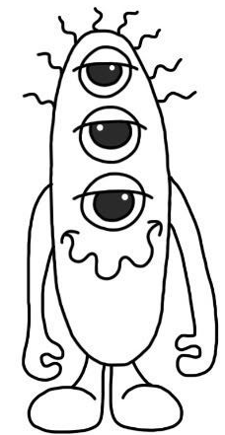

2. IT IS **ROBIN**

* It is SHORT – TALL
* It has 1 - 2 - 3 - 4 - 5 EYES
* It has SHORT – LONG HAIR
* It has 2 LONG – SHORT ARMS
* It has 1 - 2 - 3 - 4 - 5 LEGS
* It has SHORT – LONG LEGS

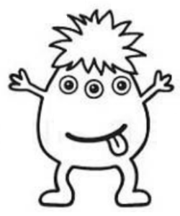

3. IT IS **JACK**

* It is BIG – SMALL
* It is SHORT – TALL
* It has 1 - 2 - 3 - 4 - 5 EYES
* It has SHORT – LONG HAIR
* It has 2 LONG – SHORT ARMS
* It has 1 - 2 - 3 - 4 - 5 LEGS
* It has SHORT – LONG LEGS

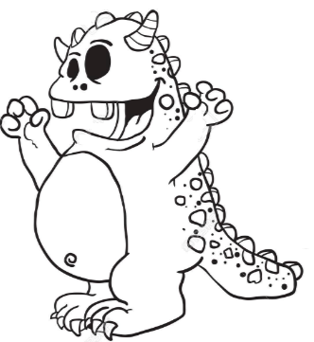

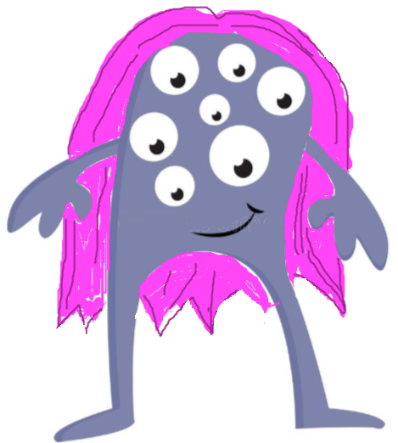

4. IT IS **MUZZY**

* It is BIG - SMALL
* It is THIN – FAT
* It has 1 - 2 - 3 - 4 - 5 EYES
* It has a BIG – SMALL MOUTH
* It has 2 LONG – SHORT ARMS
* It has SHORT – LONG LEGS

5. IT IS **YIN**

* It is RED – PURPLE
* It is TALL – SHORT
* It is THIN – FAT
* It has 1 - 2 - 3 - 4 - 5 - 6 - 7 - 8 - 9 EYES
* It has a BIG – SMALL MOUTH
* It has LONG – SHORT HAIR
* It has YELLOW – PINK HAIR.
* It has SHORT – LONG LEGS