Name: __________________________________________________________ 1stgrade

A. Write 1,2,3,4,5 or 6 in each circle to match the monster with their description.
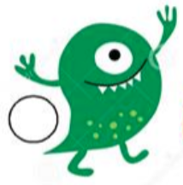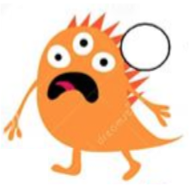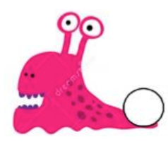
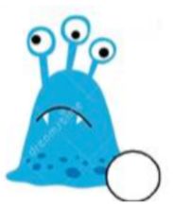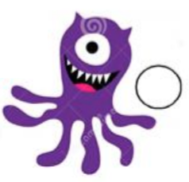

- Its name is MORRIS. It is green. It has 1 eye and 2 short legs.
- Its name is JASON. It is sad and blue. It has 3 big eyes and 0 legs.
- Its name is OCTOPUS. It is happy and purple. It has 1 eye and 6 long legs.
- Its name is TORI. It is orange. It has 2 eyes, 2 short legs and black short hair.
- Its name is SNAILY. It is pink. It has a small nose, 2 big eyes and 0 legs.
- Its name is SCARY. It has a big sad mouth, 3 big eyes and orange short hair.

B. Draw your own monster and describe it.

Its name is……………………………………………….
It is…………………………………………………………..(color)
It has………………………………………………………..eyes.
It has…………………………………………………………arms.
It has………………………………………………………….legs.
It has………………………………………………………………..
…………………………………………………………………………
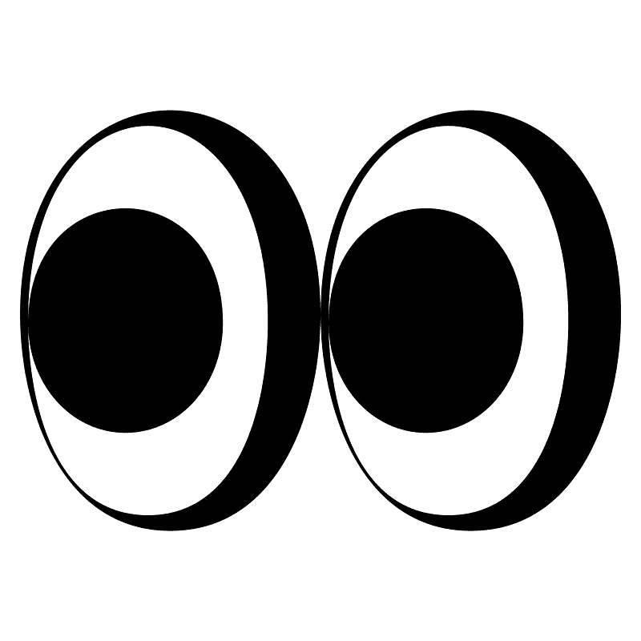
(mouth, ears, teeth, nails, hair)

