**DESCRIPTIVE WORDS**

**Name:** __________________________________________________________ 1stgrade A – B – C – D

***SHE/HE/IT IS…***

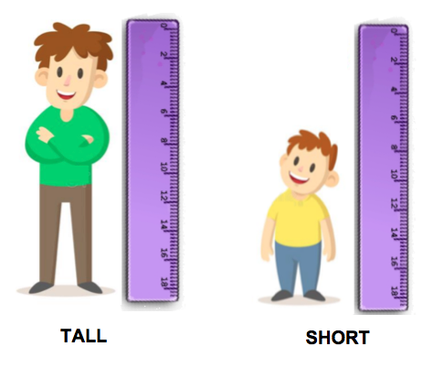

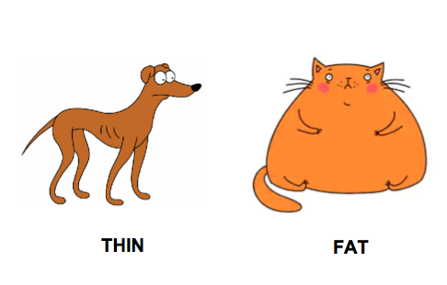

***SHE/HE/IT HAS…***

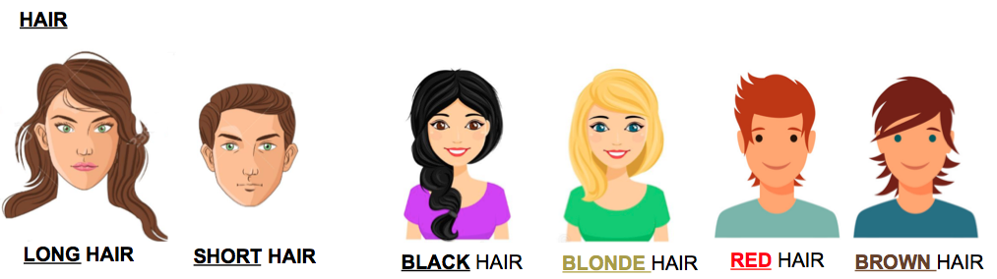

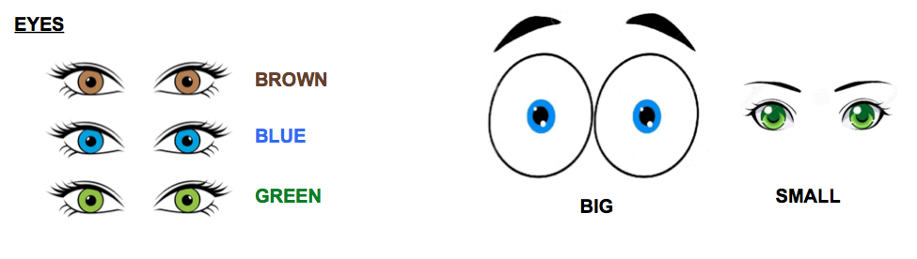

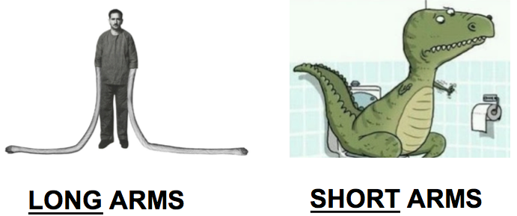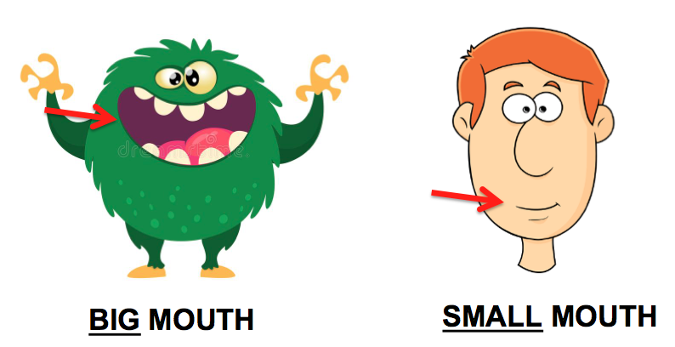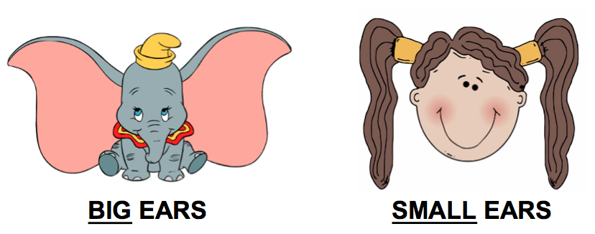

***SHE/HE/IT HAS…***