**Name:______________________________________________________________**

**ACTIONS**

1. **Read the words and color according to the instructions.**

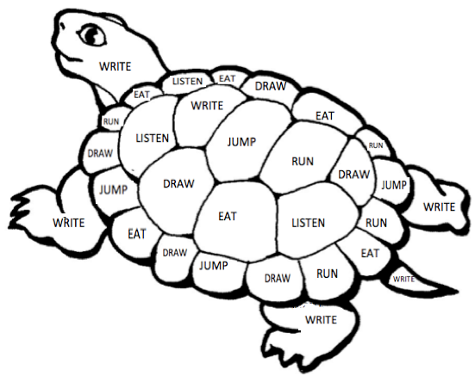

|  |  |  |
| --- | --- | --- |
| Macintosh HD:Users:Giovi:Desktop:Captura de pantalla 2020-05-17 a las 1.21.53.png | DRAW | PINK |
| Macintosh HD:Users:Giovi:Desktop:Captura de pantalla 2020-05-17 a las 1.27.19.png | JUMP | BLUE |
| Macintosh HD:Users:Giovi:Desktop:Captura de pantalla 2020-05-17 a las 1.22.26.png | WRITE | GREEN |
| Macintosh HD:Users:Giovi:Desktop:Captura de pantalla 2020-05-17 a las 1.23.21.png | RUN | ORANGE |
| Macintosh HD:Users:Giovi:Desktop:Captura de pantalla 2020-05-17 a las 1.24.38.png | LISTEN | PURPLE |
| Macintosh HD:Users:Giovi:Desktop:Captura de pantalla 2020-05-17 a las 1.28.00.png | EAT | YELLOW |