**Name:______________________________________________________________**

**ACTIONS**

1. **Match the actions with the correct places.**

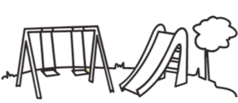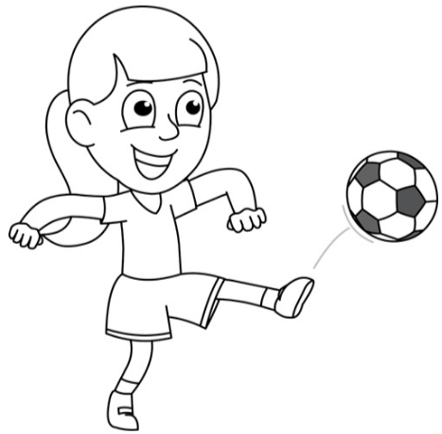

PLAYGROUND

PLAY WITH A BALL

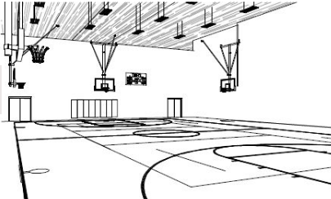

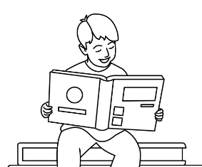

GYM

READ

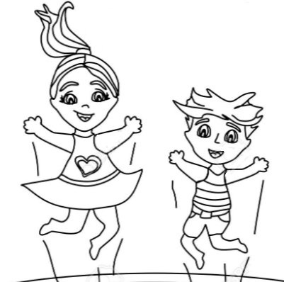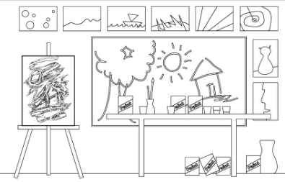

ART ROOM

JUMP

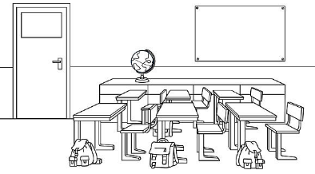

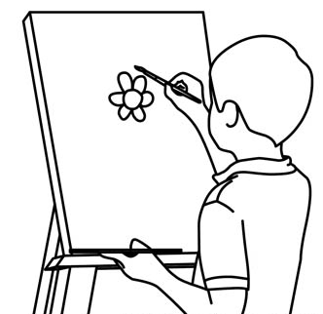

CLASSROOM

DRAW

**2) Look at the pictures and write the numbers in the correct actions.**

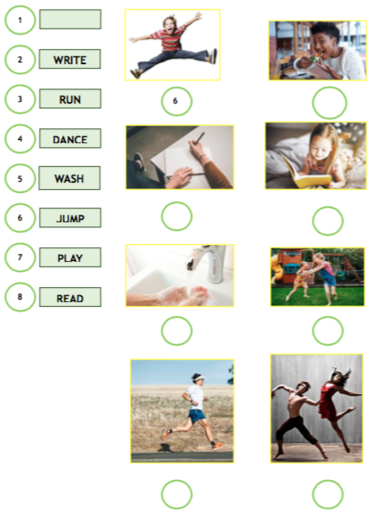

**EAT**

**3) Complete with te correct actions. Use the Word Bank.**

