**LISTENING**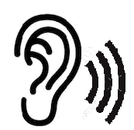

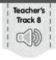**Name:______________________________________________________________**

1. **Listen to the conversation. Circle the correct picture to complete each sentence.**
2. **The children are going to meet the…**

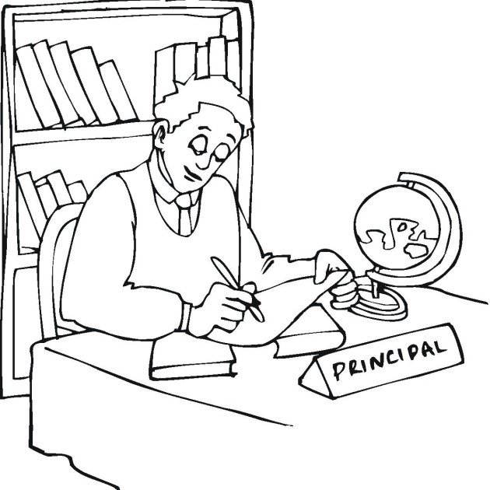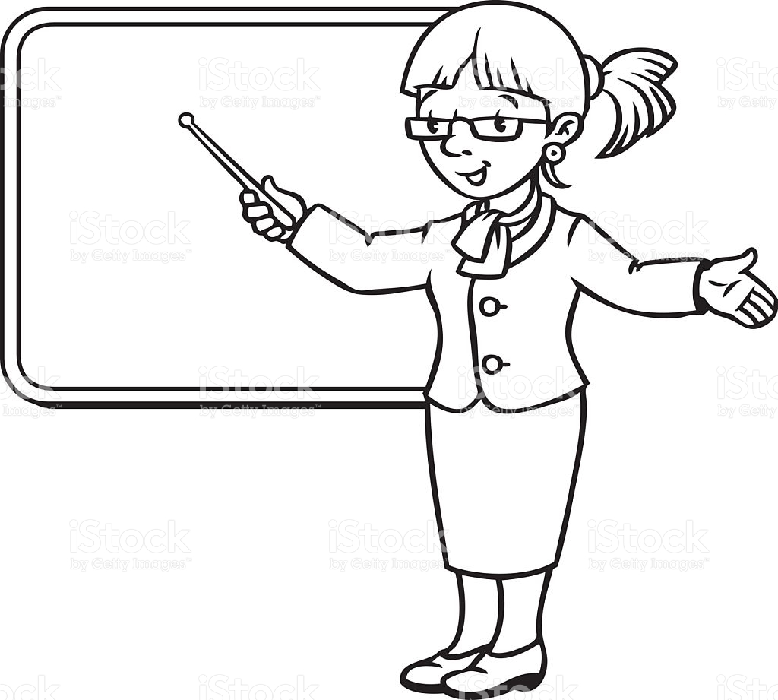

**PRINCIPAL TEACHER SECRETARY**

1. 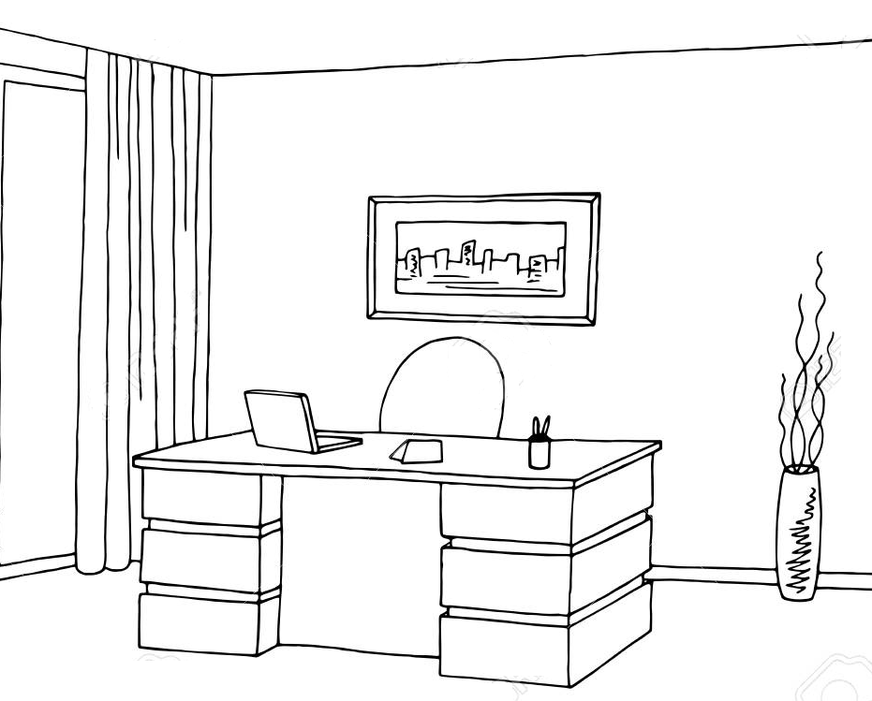**Anna wants to look for him in his…**

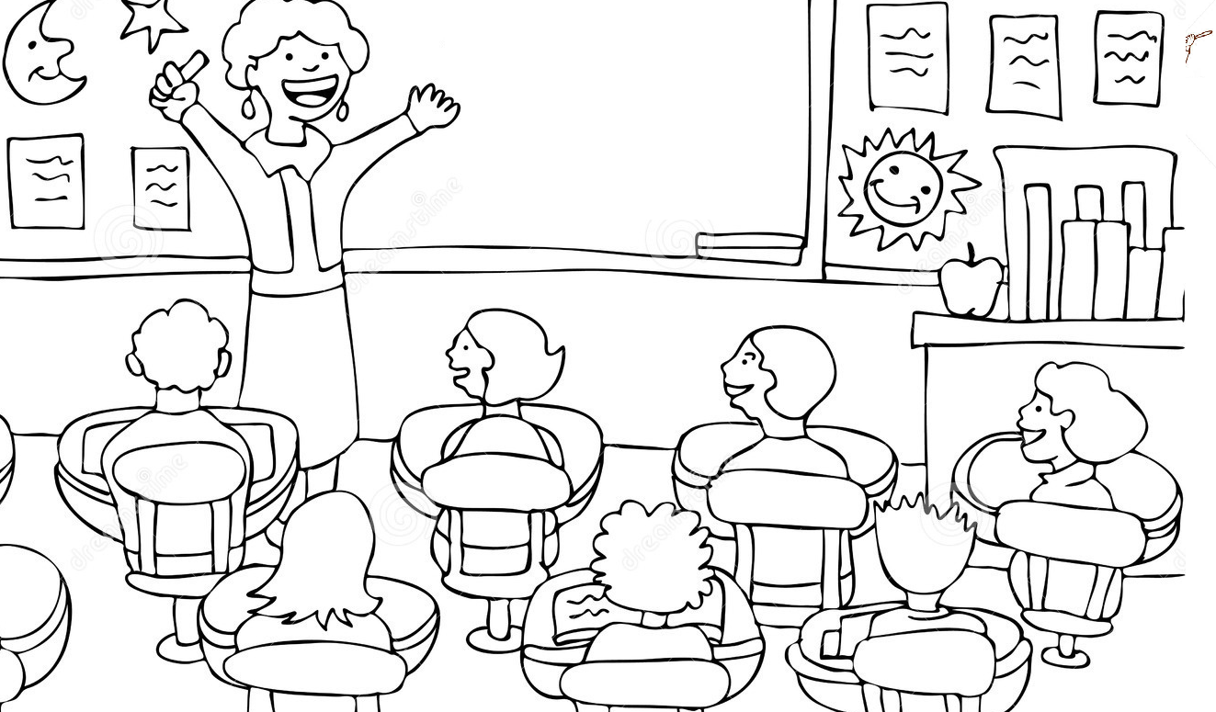

**HOUSE CLASSROOM OFFICE**

1. **Kate wants to drink…**

  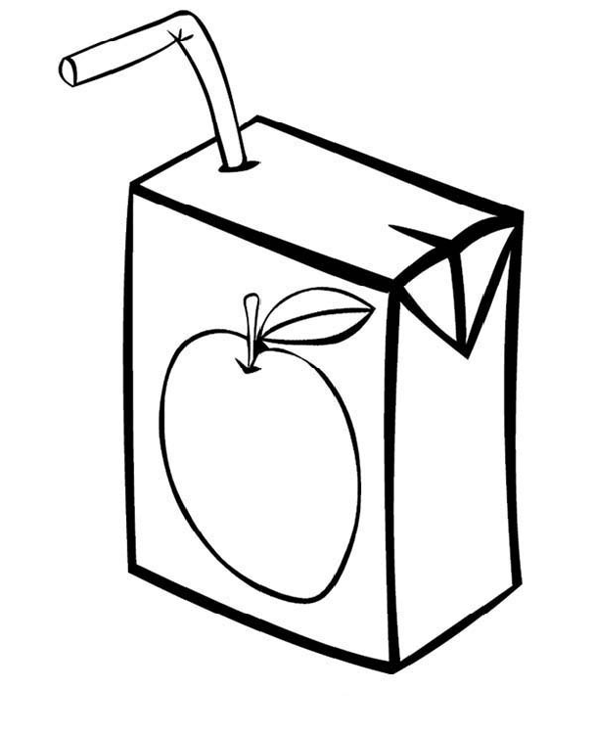

**SODA WATER JUICE**

1. **The children are going to the…**

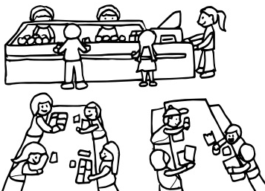 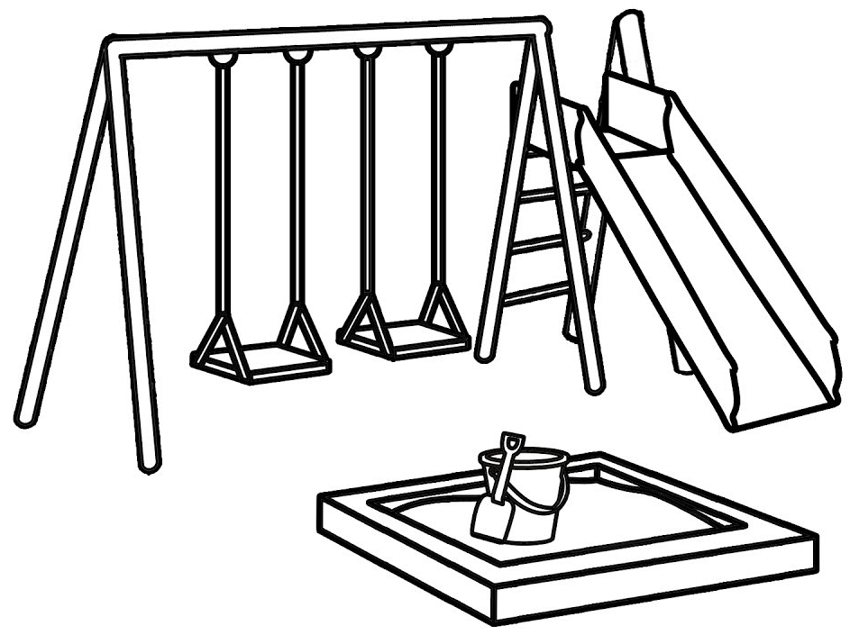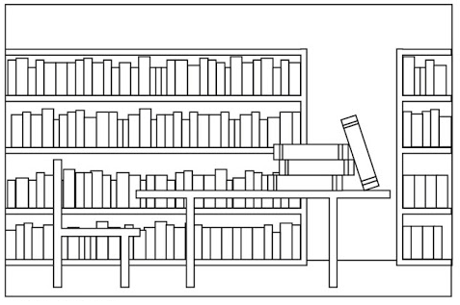

**CAFETERIA PLAYGROUND LIBRARY**

1. **How does the principal feel? Color the correct feeling**

   