**LISTENING**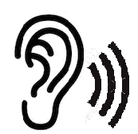

**Name:______________________________________________________________**

1. 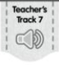**Listen to the conversation. Circle the correct picture to complete each sentence.**
2. **Ms. Avery is a …**

 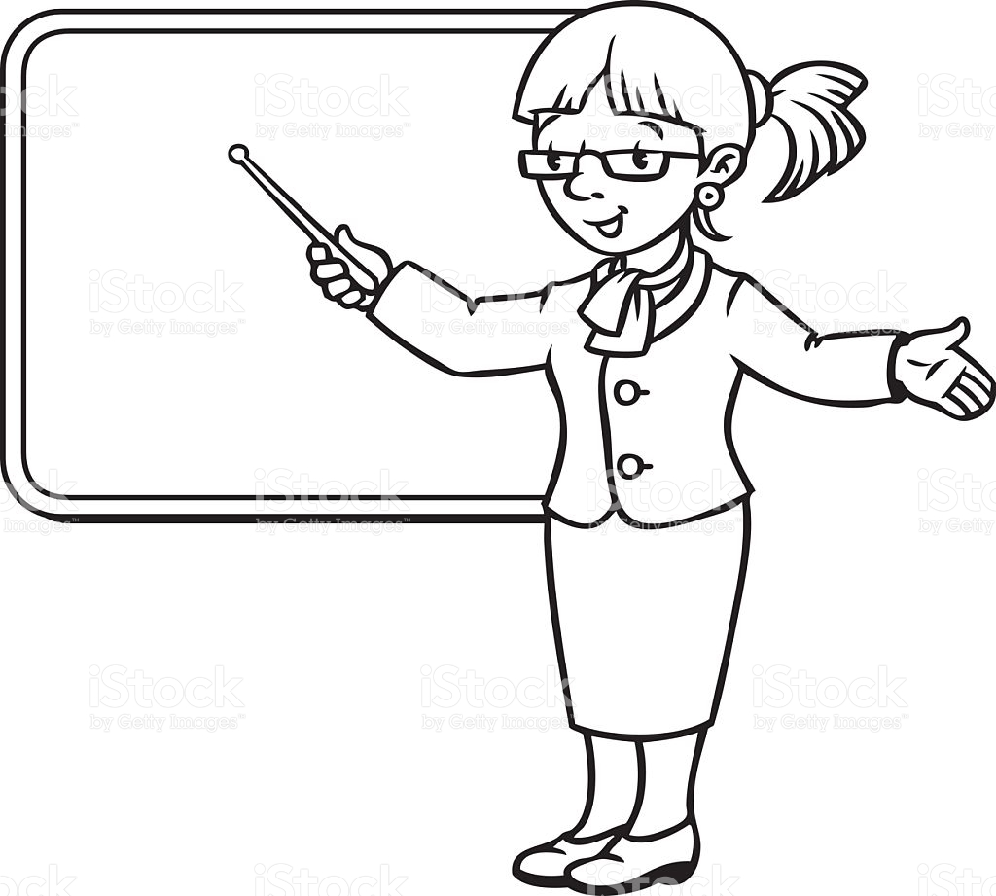

**NURSE TEACHER CHEF**

1. **Where are they?**

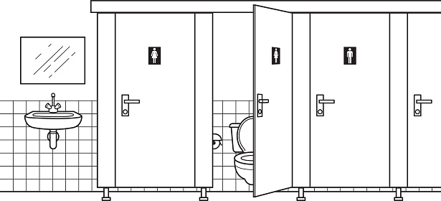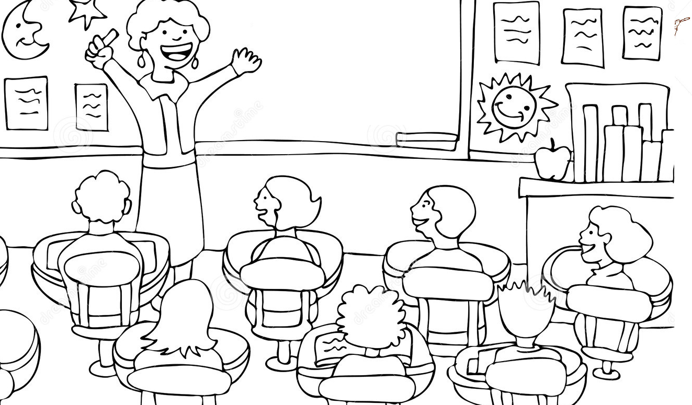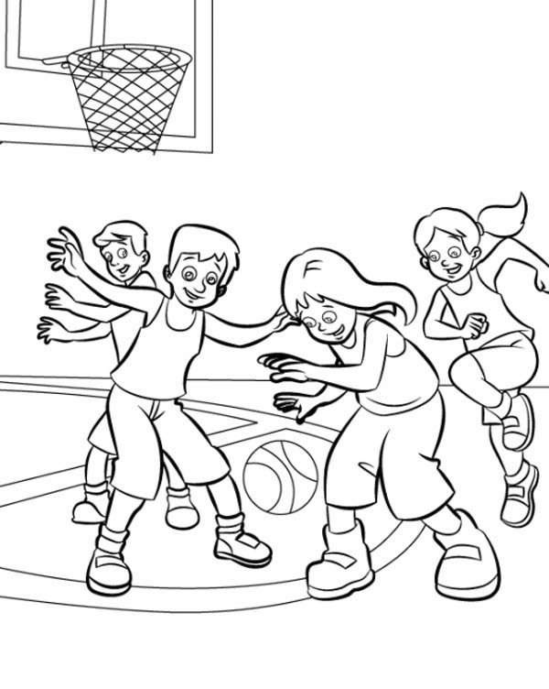

**GYM BATHROOM CLASSROOM**

1. **There are_________books for Tony.**



**5 books 7 books 3 books**

1. **Anna has________pencils on her desk**

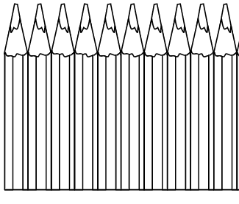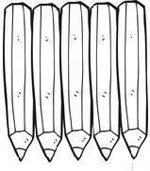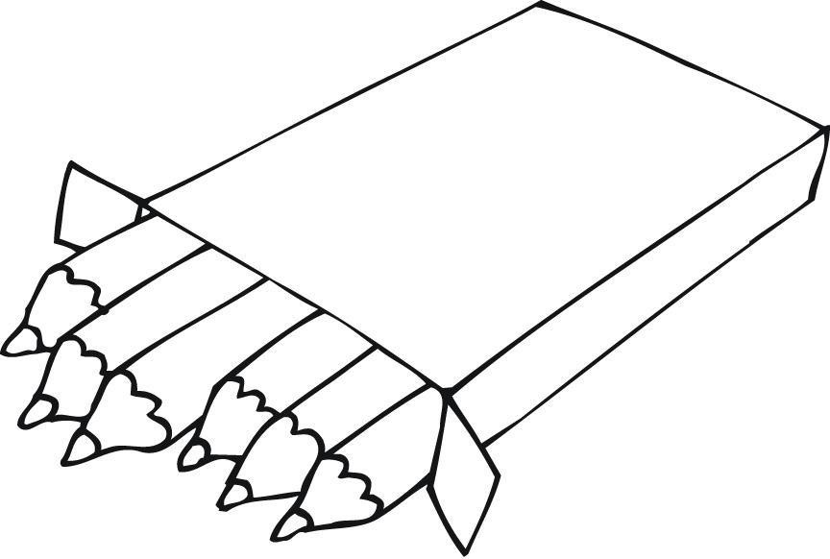

**6 pencils 10 pencils 4 pencils**

1. **How does Ms. Avery feel? Color the correct feeling**

  