Name: __________________________________________________________ 1stgrade

PETS VOCABULARY:
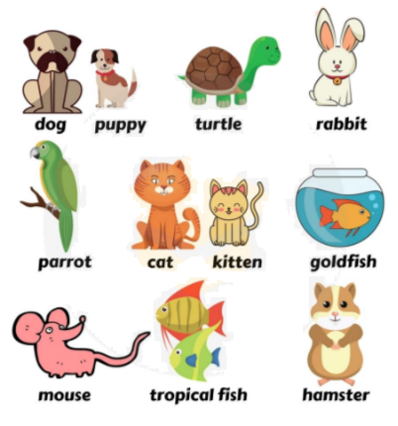
bird

Match the pictures with the correct word.

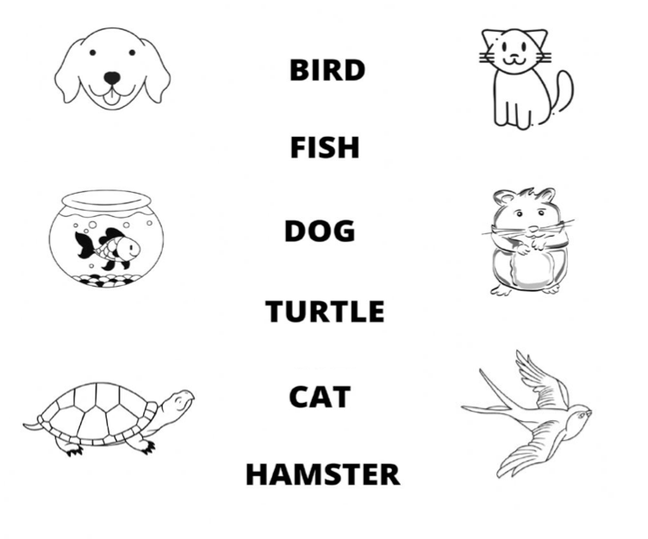

Name: __________________________________________________________ 1stgrade

PETS BODY PARTS:

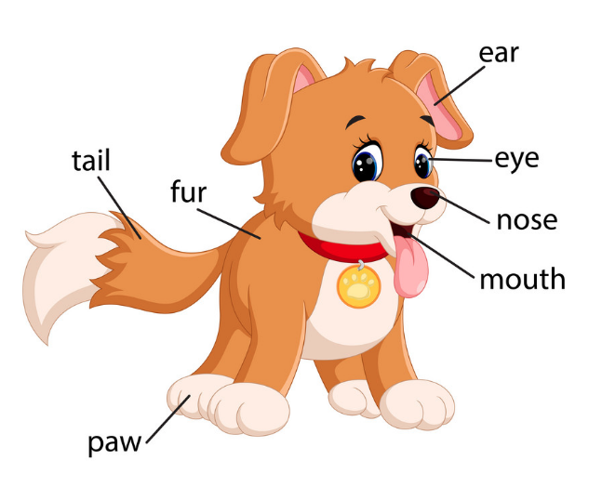
legs
tongue

1. Number the body parts of the dog

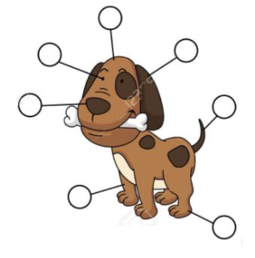

- EARS
- HEAD
- EYES
- NOSE
- PAWS
- TAIL
- LEGS
2. Write the body parts of the cat.

