Pre Kinder – Zoom Class
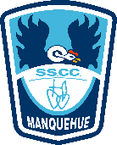
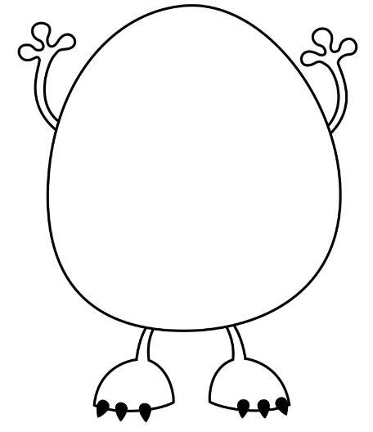
Listen to the teacher and follow the instructions to create your monster.

