Name:_______________________________________ Grade:_________.
WHAT IS YOUR FAVORITE FOOD?
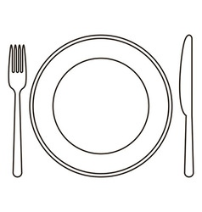
Draw your favorite food on the plate and then color.

