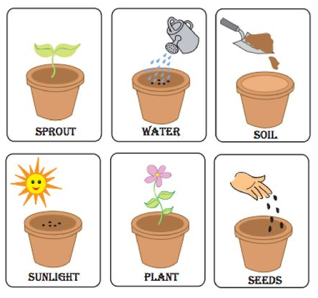

1. Cut out the images and observe them. Then, paste them in the correct order to complete the sequence on the next page.

|  |  |  |
| --- | --- | --- |
| **1** | **2** | **3** |
| **4** | **5** | **6** |

Paste the images here in the correct order.

|  |
| --- |
|  |

1. Draw the season mentioned in the story. Color and decorate.