|  |  |  |  |  |  |
| --- | --- | --- | --- | --- | --- |
| **R** | **A** | **T** | **Ó** | **N** | **Z** |
| **U** | **Y** | **Z** | **Q** | **W** | **X** |
| **L** | **G** | **H** | **K** | **Ñ** | **W** |
| **E** | **D** | **R** | **A** | **M** | **A** |
| **T** | **Y** | **X** | **Q** | **Ñ** | **Y** |
| **A** | **R** | **E** | **L** | **O** | **J** |



**Sopa de letras**

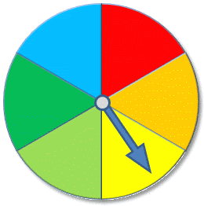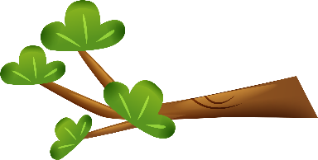

**RATÓN**

**RELOJ**

**RULETA**

**RAMA**