4º Grade: The Tale of Mr. Morton
Objective 1: Identify and classify regular and irregular verbs to express situations that happened in the past.
Objective 2: Identify general and specific information in a song to demonstrate listening skills
You can complete the activity in this document. You don’t have to print it

STEP 1: Look at the pictures and complete the routine SEE -THINK-WONDER

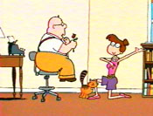
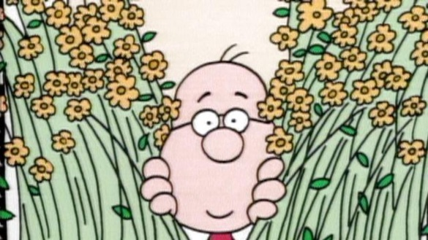
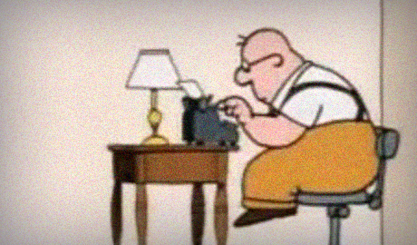

I SEE … | I THINK … | I WONDER …
I see a man sitting and using a typewriter  I see a man with his head between flowers  I see a girl on her knees  I see a Man with a flower in his hands  I see a cat on the floor | I think the man is writing a letter  I think the man is looking at the girl  I think the girl is telling the man that she loves him | I wonder if the man is writing a love letter?  I wonder if the girl is proposing?  I wonder if they are neighbors?

STEP 2: Click on the link to the video https://www.youtube.com/watch?v=sk-XA5pKkGE watch and listen.

STEP 3: Now listen again and complete with the verbs in past from the box.

The Tale of Mr. Morton
(Jack Sheldon)

This is the tale of Mister Morton
Mister Morton is who?
He is the subject of our tale
and the predicate tells what Mister
Morton must do
Mister Morton _walked_ down the street
Mister Morton walked
Mister Morton __talked__ to his cat
Mister Morton talked
(Hello, cat. You look good.)
Mister Morton was lonely
Mister Morton was
rhymed – talked - grew - wrote

was - climbed - replied

sat - knocked - knew

walked- ran - wrote

Mister Morton is the subject of the
sentence and what the predicate says,
he does
Mister Morton __knew__ just one girl
Mister Morton knew
Mister Morton __grew__ flowers for Pearl
Mister Morton grew
Mister Morton ___was_ very shy
Mister Morton was
Mister Morton is the subject of the
sentence and what the predicate says,
he does
The subject is a noun, that's person,
place or thing
It's who or what the sentence is about
And the predicate is the verb
That's the action word
that gets the subject up and out

Mister Morton __wrote_ Pearl a poem
Mister Morton ____wrote____
Pearl replied in the afternoon
Pearl __replied__ by a note
Mister Morton was very nervous
Mister Morton was
Mister Morton is the subject of the
sentence and what the predicate says,
he does!

The cat stretched,
the sun beat down,
a neighbor chased his kid.
(come here kid - come on!)
Each sentence is completed when
you know the subject did.
Mister Morton __knocked___ on her door
Mister Morton knocked
Mister Morton sat on her porch
Yes, he just __sat__ and rocked
Mister Morton was a nervous man
when she __opened__ up the door he _ran__.
Mister Morton climbed up his stairs
Mister Morton __climbed__
Mister Morton rhymed pretty words
Mister Morton __rhymed___
Mister Morton was lonely
Mister Morton was
until Pearl showed up with a single
rose.
Who says women can't propose?
Now Mister Morton is happy
and Pearl and the cat are too
They're the subjects of the sentence
and what the predicate says, they do!!

STEP 4: Write the number of the scenes in the correct order.
STEP 5: Write the corresponding sentence in past according to the video and pictures.
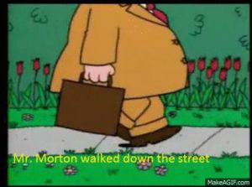

Mr. Morton walked down the street

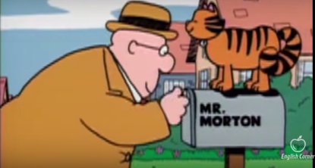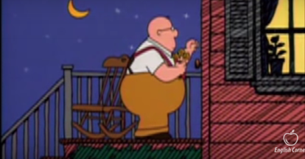
1 4
___Mr. Morton talked to his cat ____ ____Mr. Morton knocked on her door____

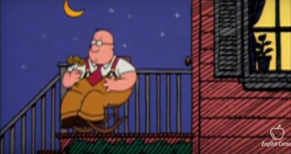
5 2
___Mr. Morton sat (and rocked) _____ _Mr. Morton wrote Pearl a poem____
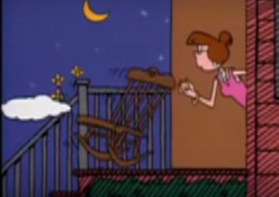
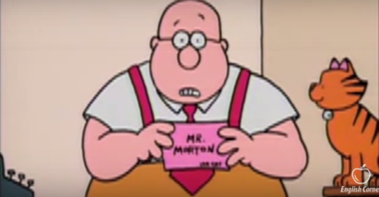
3 6
_____Mr Morton was very nervous _____ _____She opened the door ___

STEP 6: Make a list of past verbs from Mr. Morton’s song and classify them into regular and irregular.
VERBS IN PRESENT | VERBS IN PAST | REGULAR OR IRREGULAR
walk | walked | regular
talk | talked | regular
to be | was/were | irregular
know | knew | irregular
grow | Grew | irregular
write | wrote | irregular
reply | replied | regular
knock | knocked | regular
sit | sat | irregular
open | opened | regular
run | ran | irregular

STEP 7: Metacognition: think, circle and answer. NO CORRECT OR INCORRECT ANSWER, IT’S FOR YOU TO THINK ABOUT YOUR OWN LEARNING PROCESS!
NO
YES
Did you complete the activity?
First read and then listen
Listen and read at the same time
First listen and then read
How did you do it? What strategies did you use?

Complete the routine see think wonder
Write the numbers and sentences in the pictures
Complete the chart with the regular – irregular verbs
Complete the lyrics of the song
What is the most difficult part? Why?

Why is important to learn verbs (regular an irregular) in past?
Because you can speak about the past, you can express situations or events that already happened

REMEMBER!
If you need help or if you have questions you can write me an email
Miss Josefa josefa.barrera@ssccmanquehue.cl

