Unit 5: “A Very Special Present”

Name: ______________________________________________________ 2nd A – B -C -D

- Read the words in the word bank and complete the images with their name.

PETS
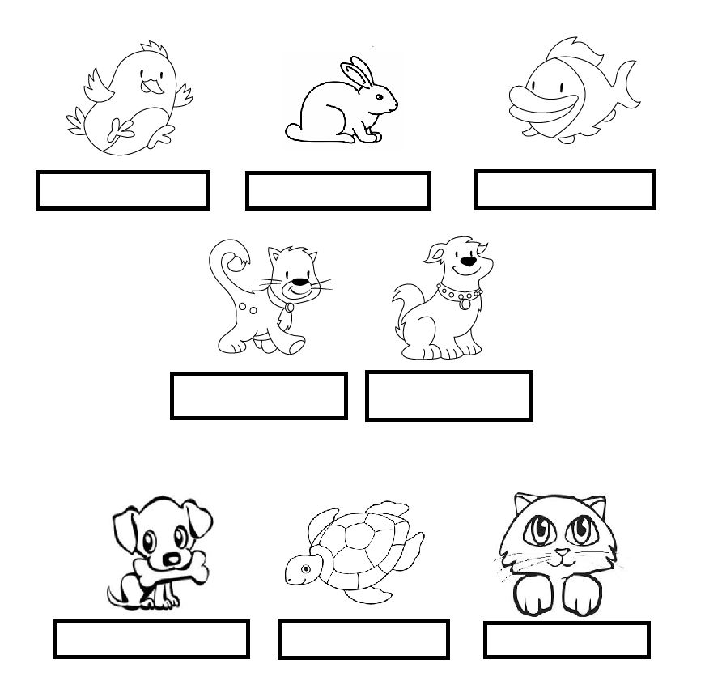
puppy | cat | fish | turtle
rabbit | dog | kitten | bird

- Read the words in the word bank and complete the images with their name.

WILD ANIMALS

tiger | elephant | gorilla | giraffe
whale | zebra | snake | dolphin
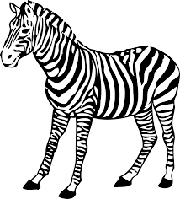

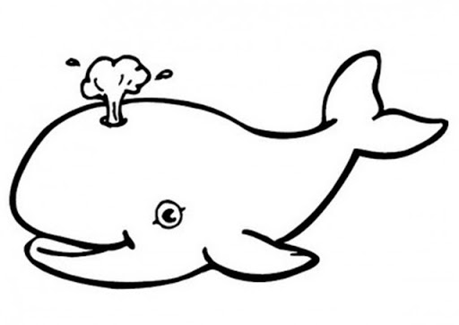
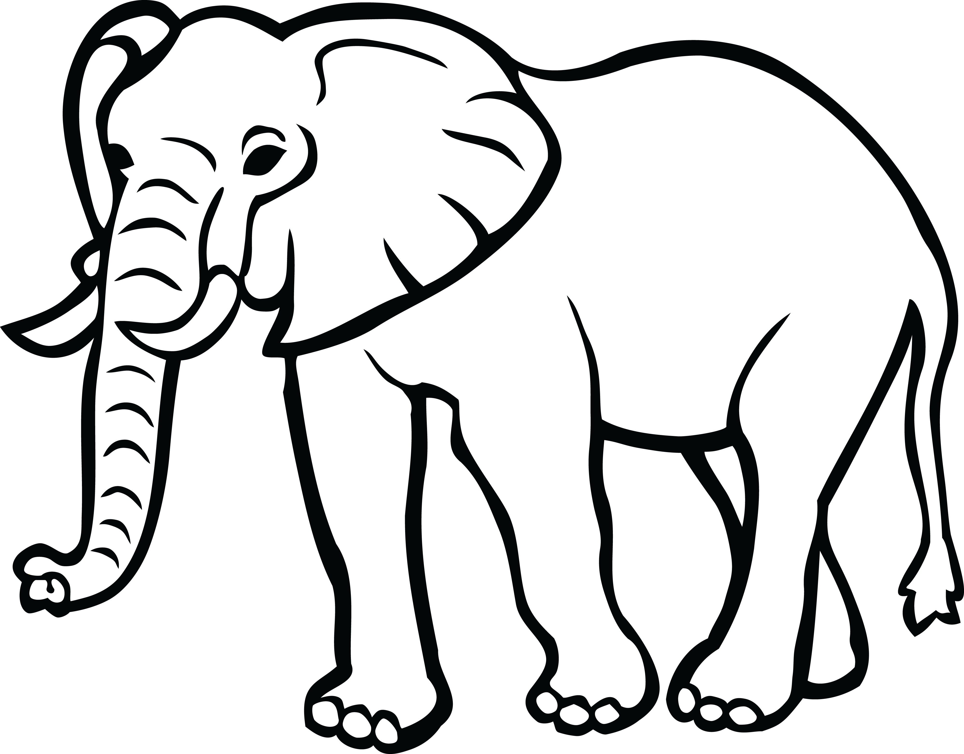

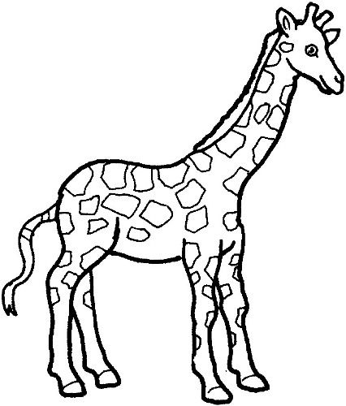
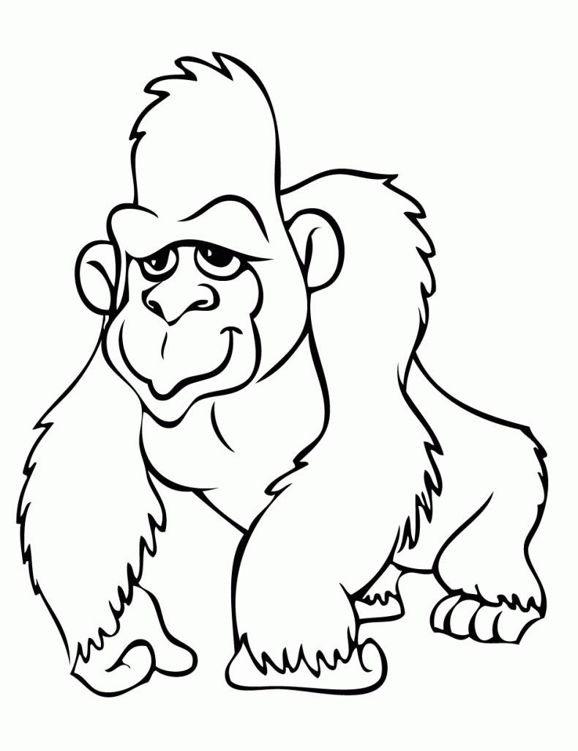
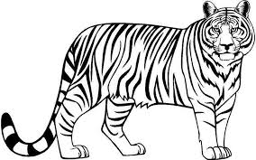

- Find the different pets in the word search.
PUPPY | TIGER | FISH | GORILLA
ELEPHANT | DOG | TURTLE | SNAKE
CAT | DOLPHIN | GIRAFFE | RABBIT

