Unit 2: Study guide

Name: ________________________________________________ 2nd grade Date: May, 8th 2020

- Read the words in the box. Cut and paste 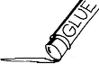 them in the correct picture.

scissors | whiteboard | backpack | pencil
eraser | book | playground | bookcase

_ _ _ _ _ _ _ _ _ _ _ _ _ _ _ _ _ _ _ _ _ _ _ _ _ _ _ _ _ _ _ _ _ _ _ _ _ _ _ _ _ _ _ _ _ _ _ _ _ _ _ _ _ _ _ _ _
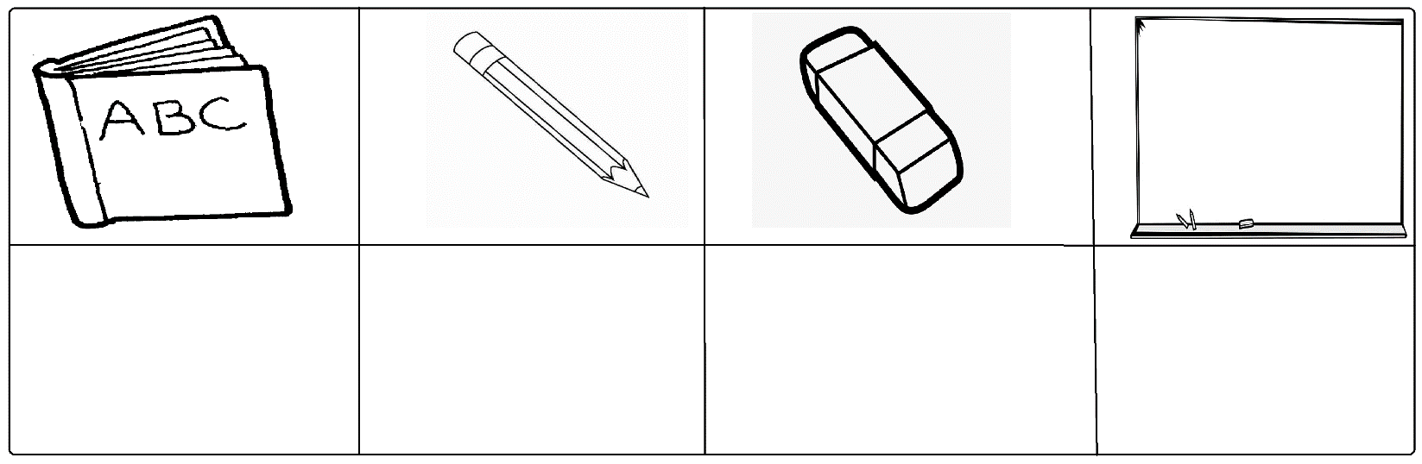
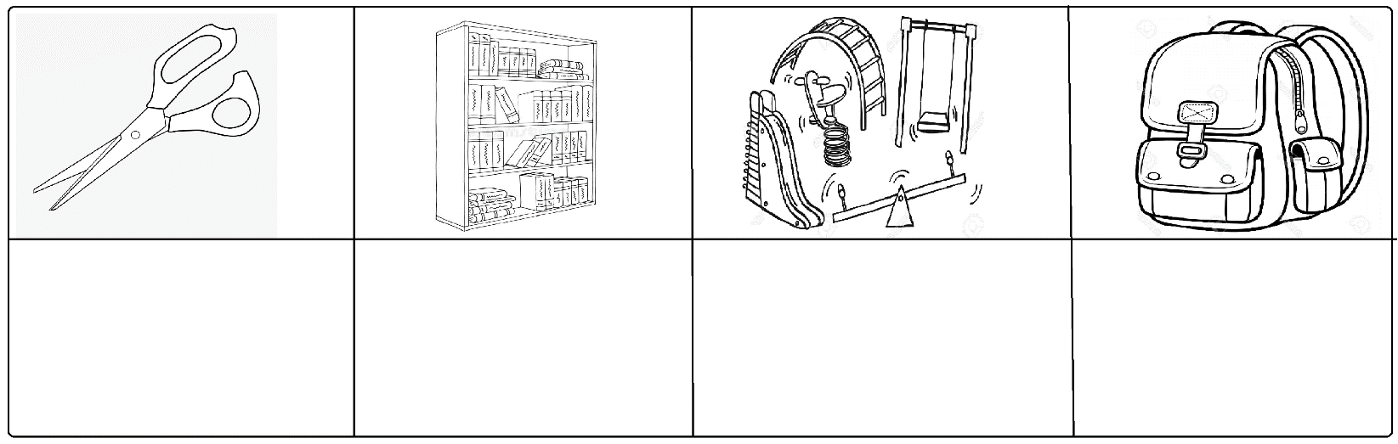
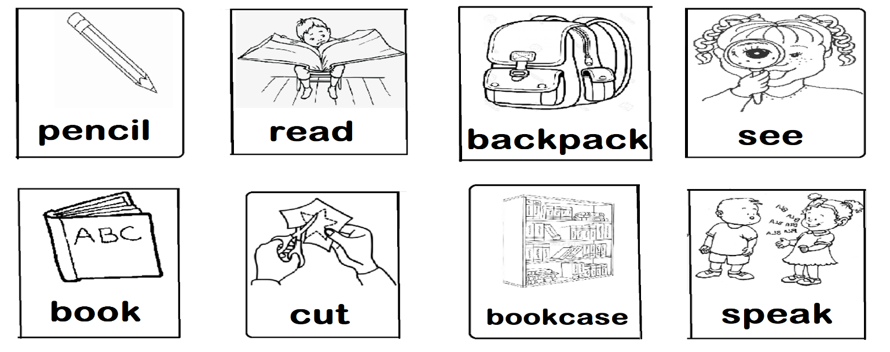
- Look at the pictures and classify them into actions or school things. Cut and paste them

Book pages
(If you have your book at home do not print this part)

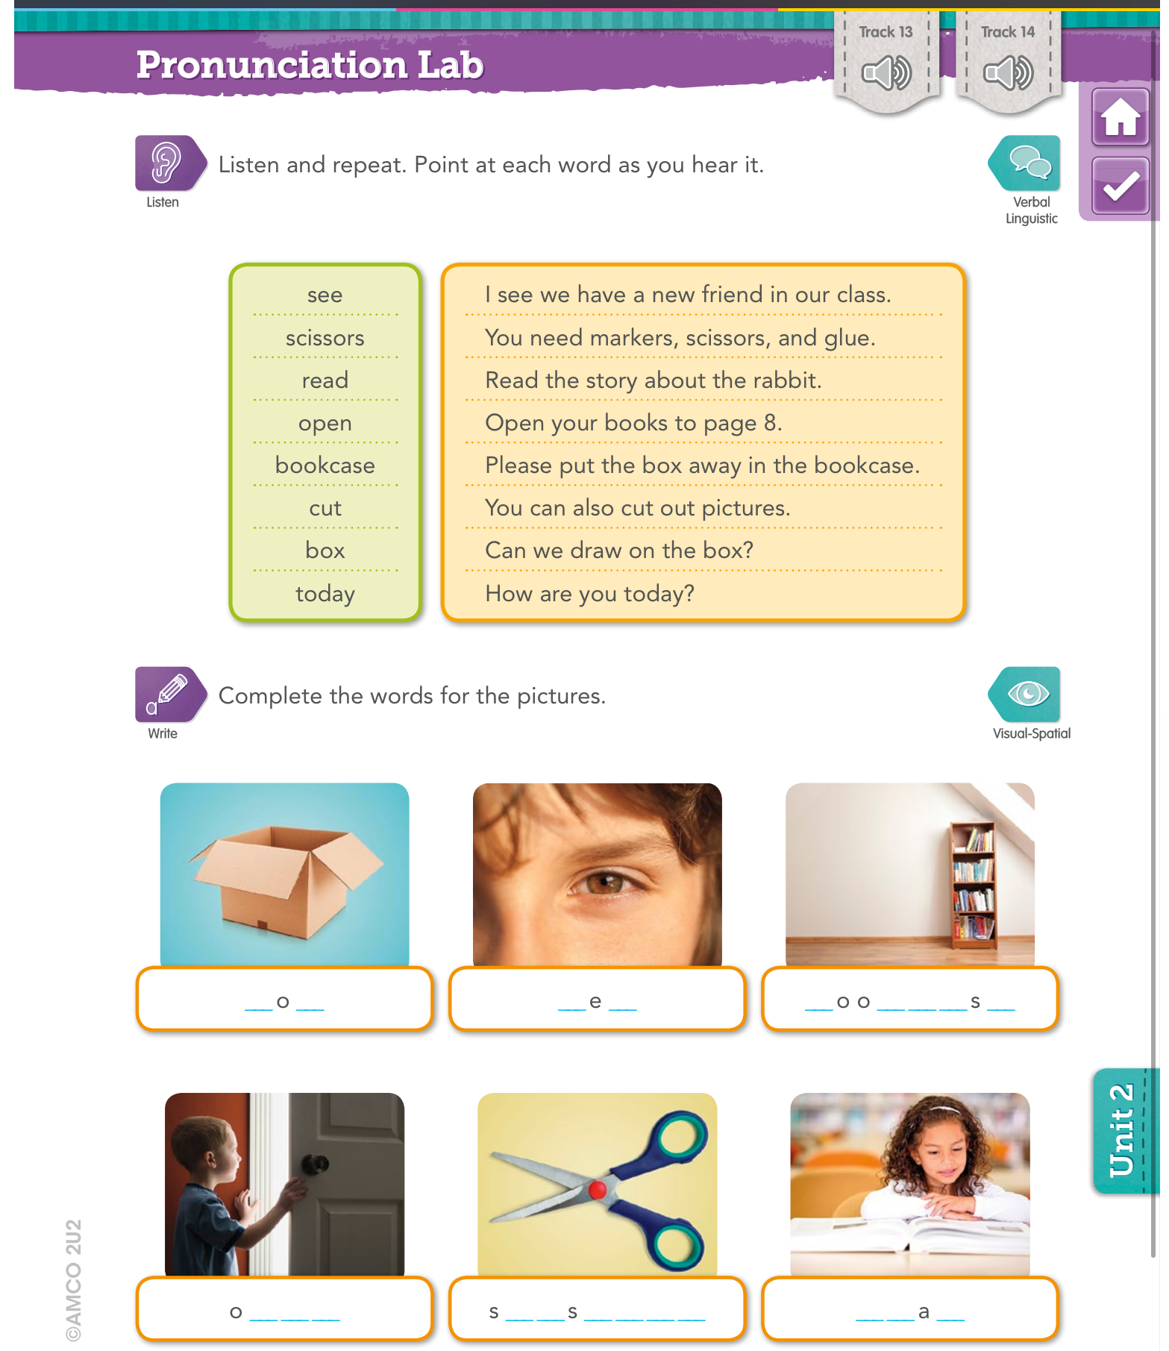
Page 62
Page 63

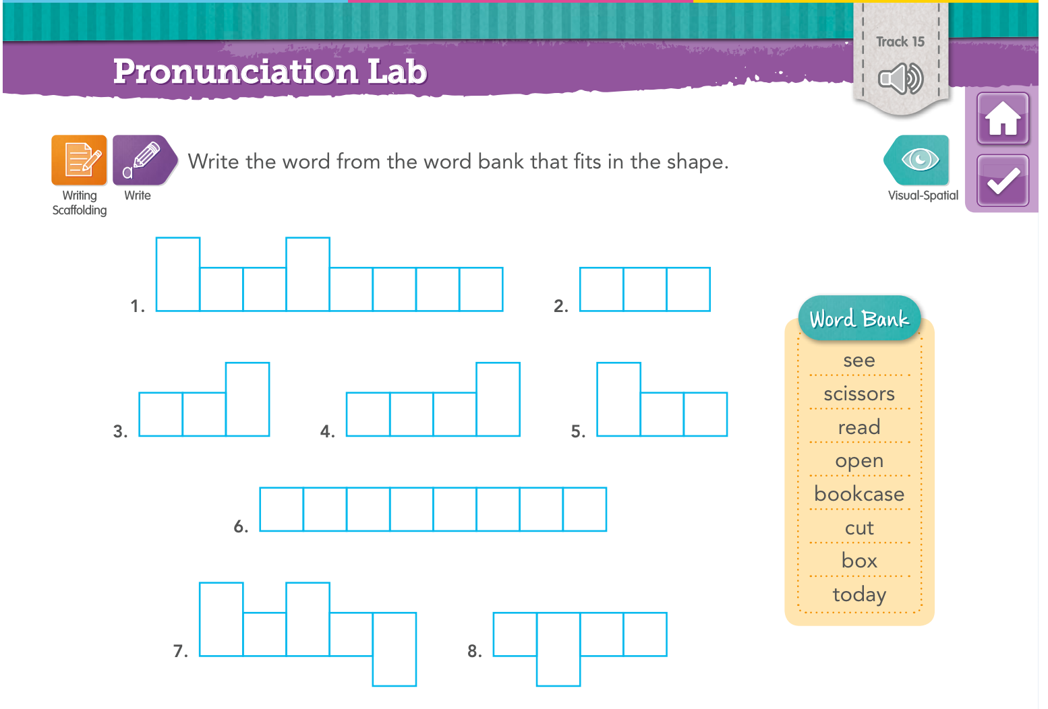

Page 61
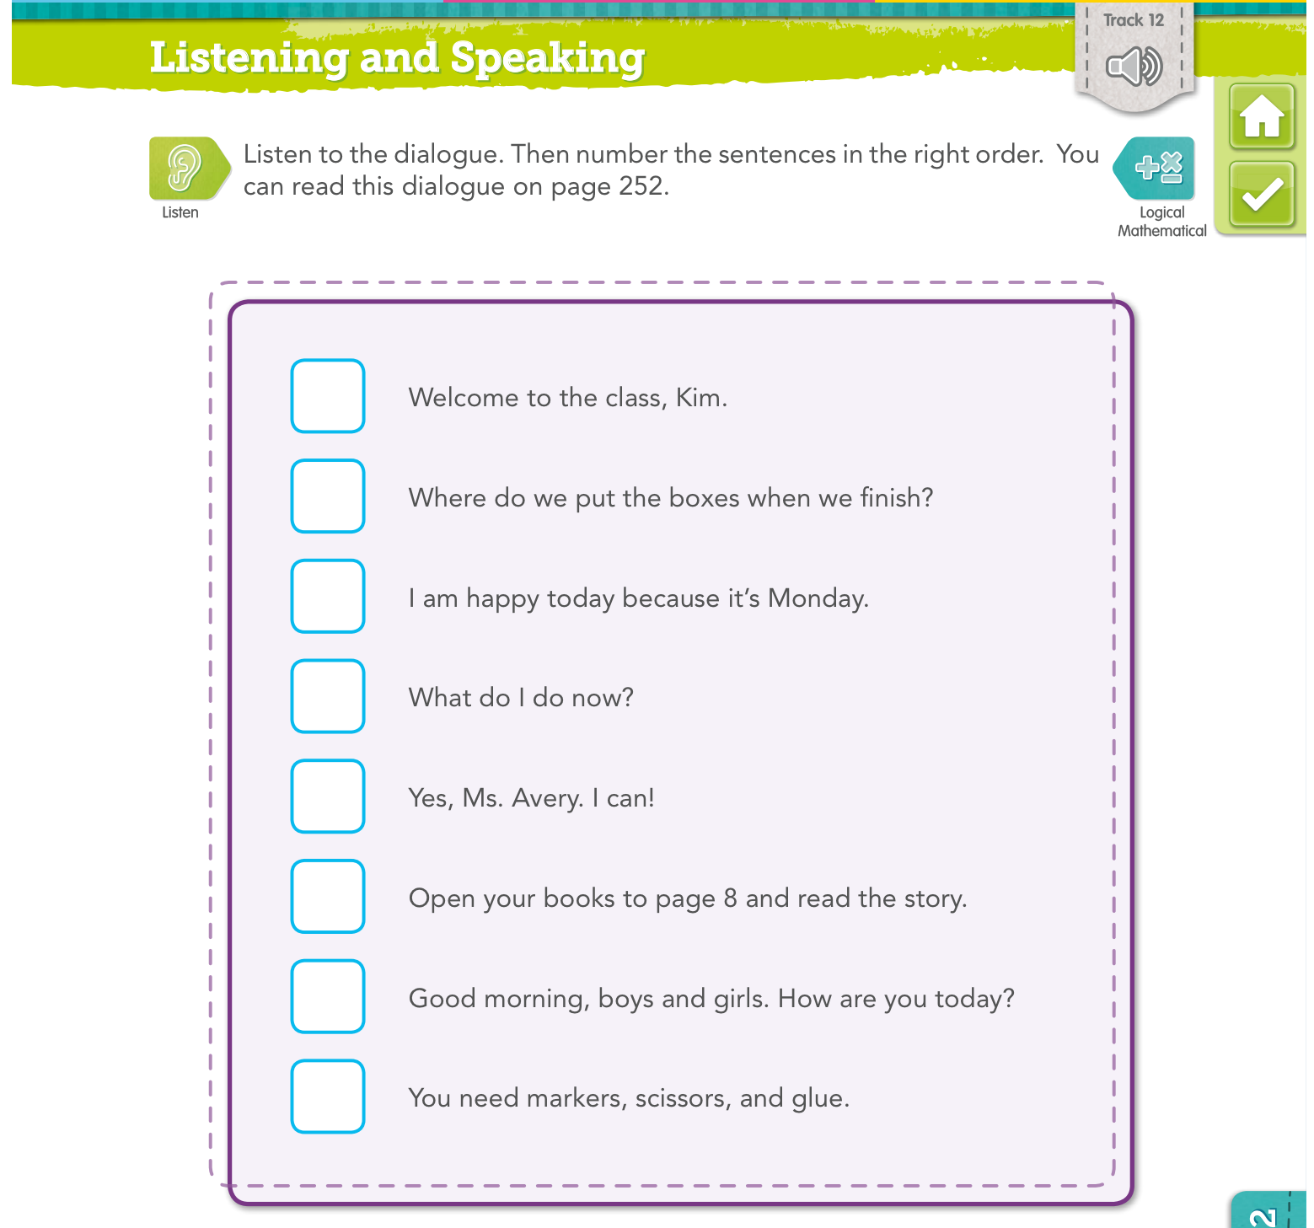

Page 65

