Unit 2: Study guide

Name: ______________________________________________ 2nd grade Date: May, 15th 2020

- If you have your book, do not print these pages.

- Read the story. (Page 70)
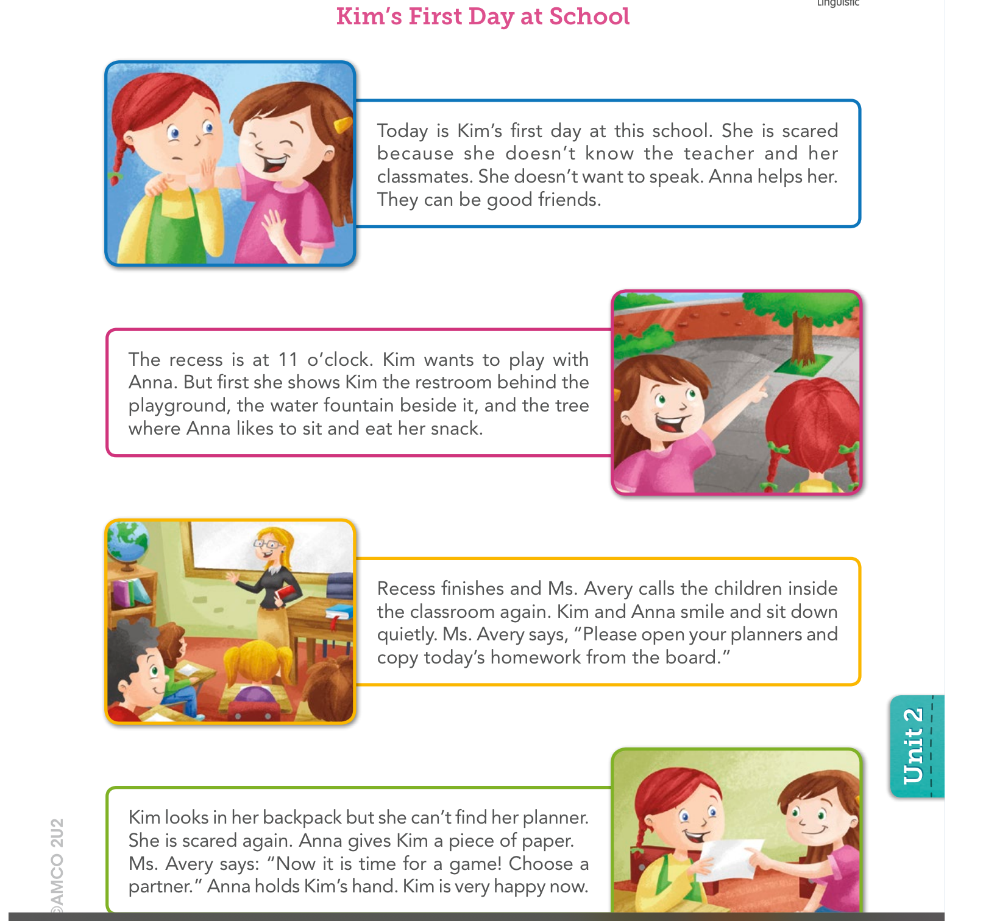

- Read the story again. Look at the pictures and put them in the correct order using the numbers 1, 2, 3 and 4. (Page 71)
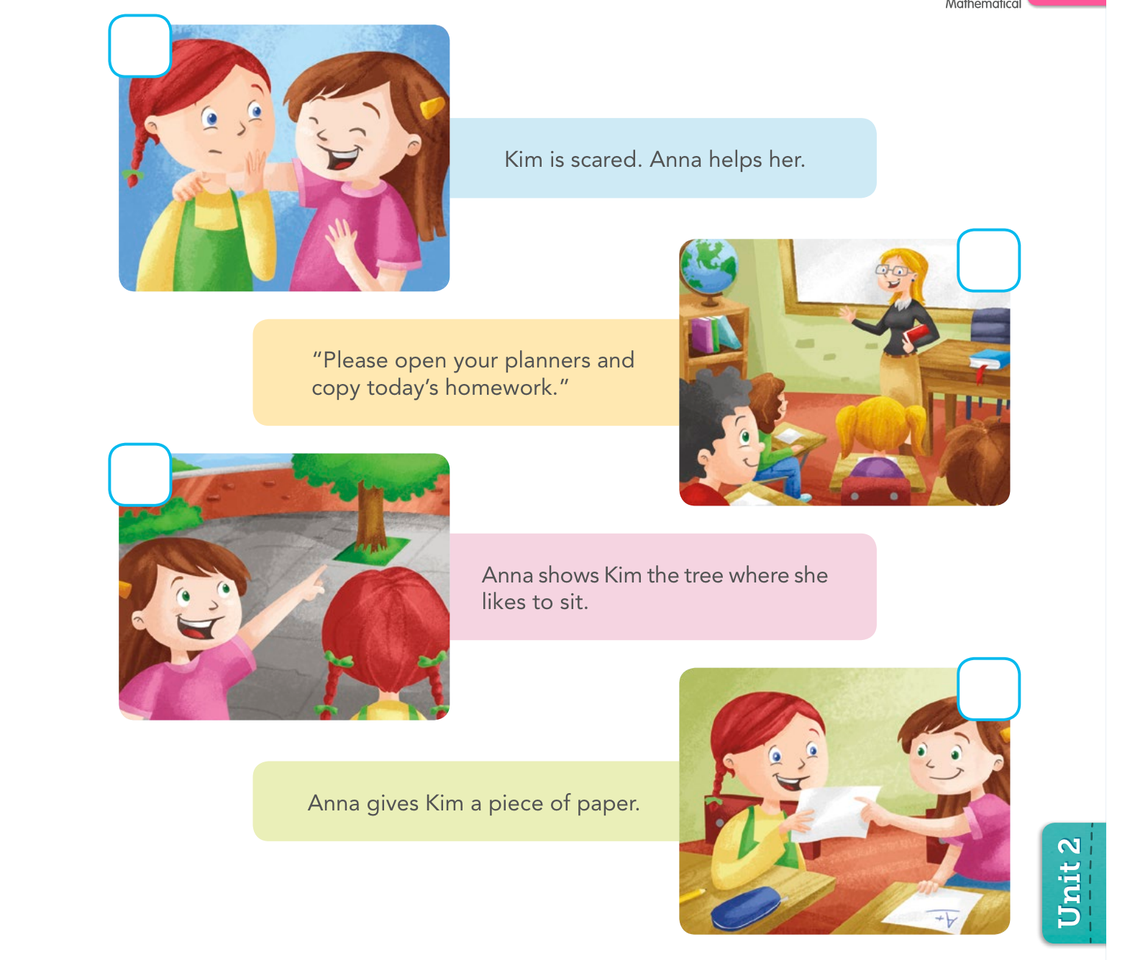

- Read the story again. Circle the correct alternative to complete the sentences. (Page 73)
