Unit 4: Study guide
Name: __________________________________________________________ 2nd grade.

- Pictionary.
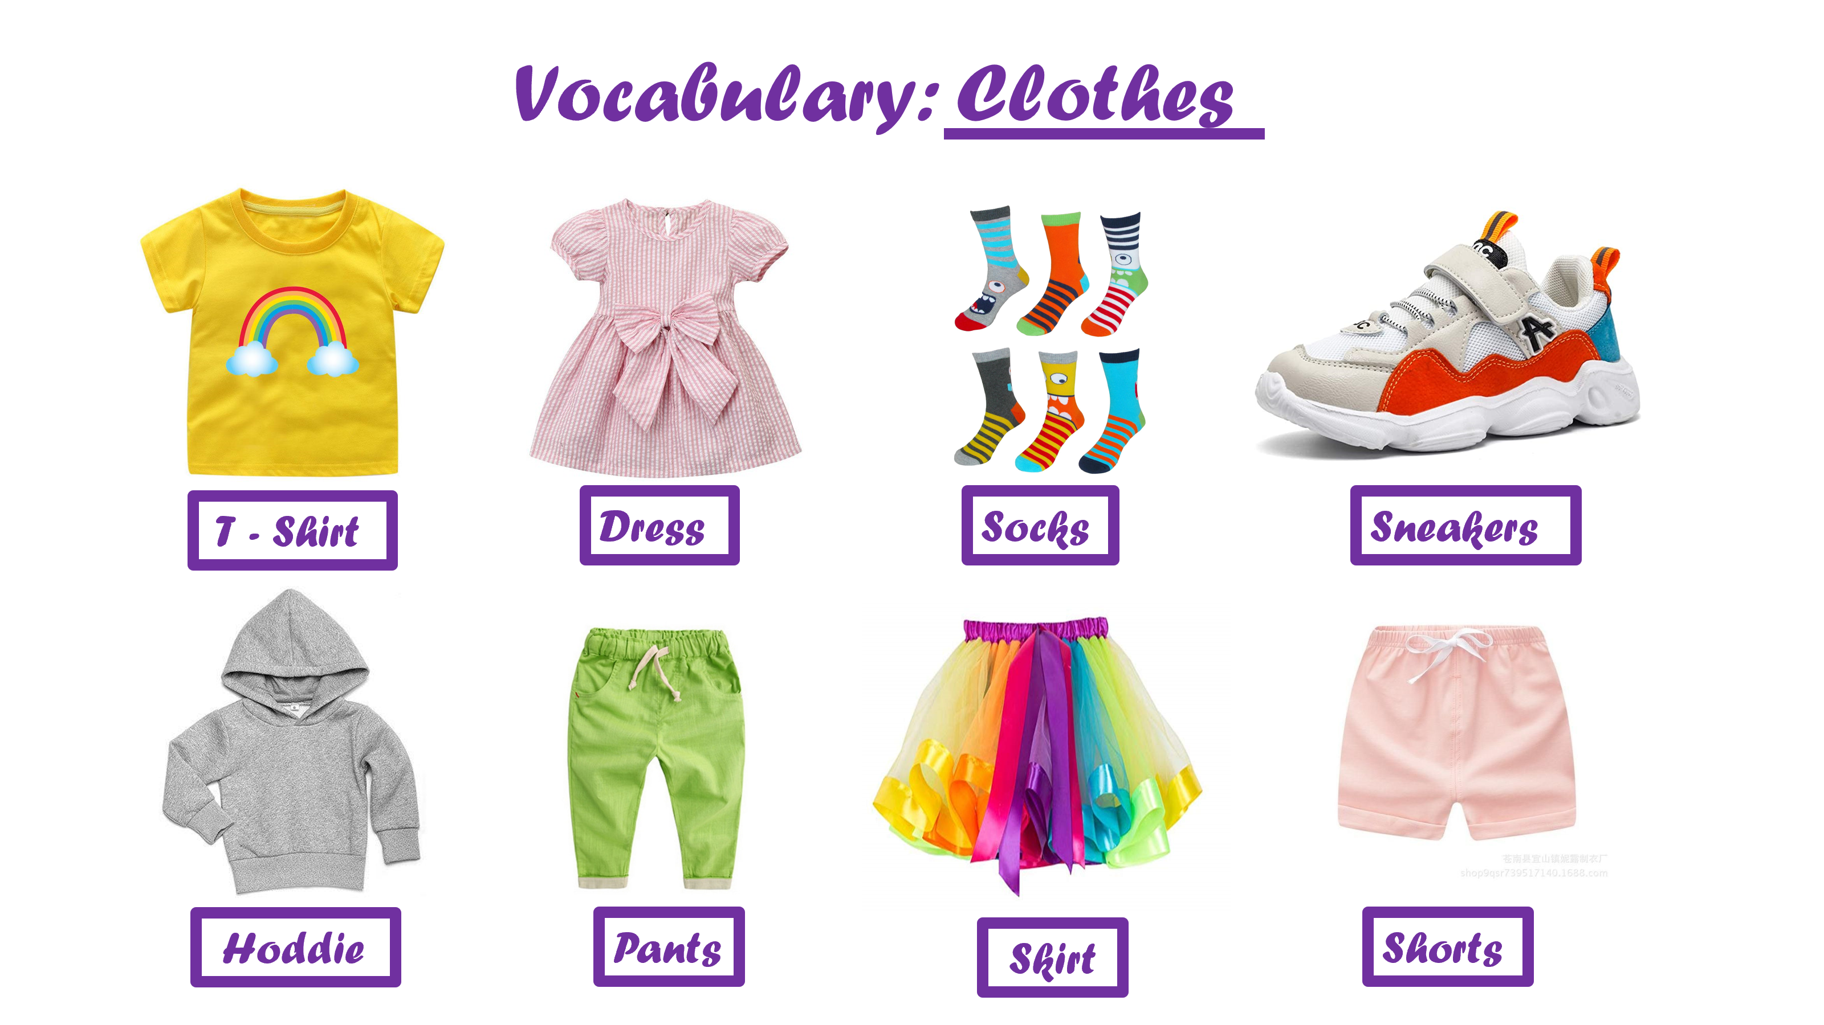

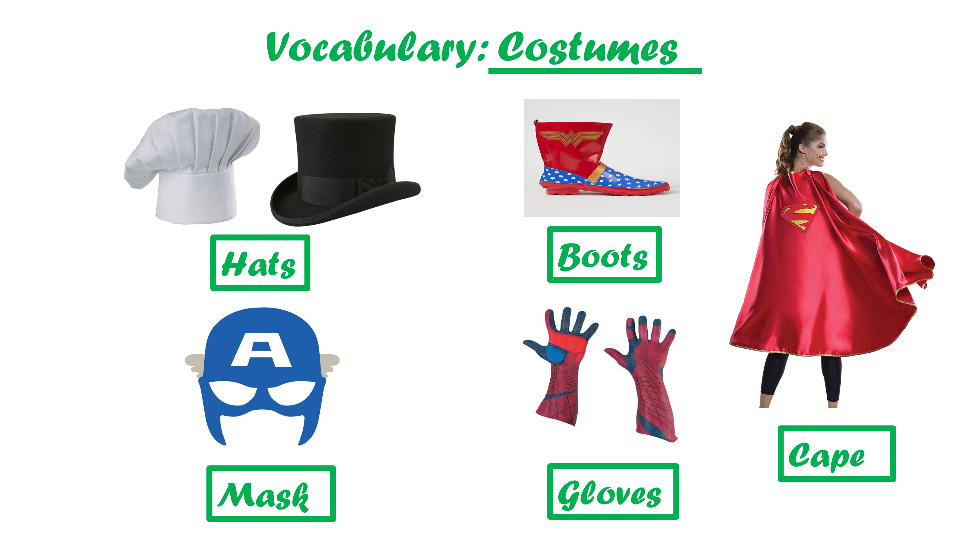
- Read the description and draw what the boy / girl is wearing.

- She is wearing a yellow hoddie, blue pants, red sneakers, and a green cape.
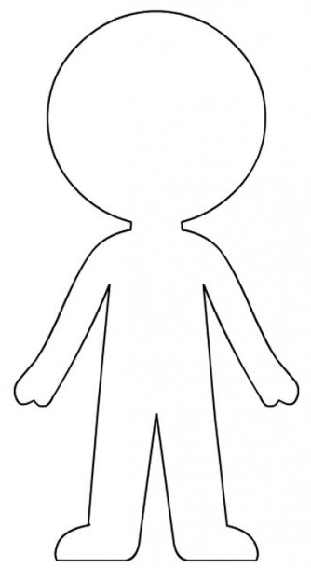

- He is wearing a purple T-Shirt, green shorts, red socks, and blue sneakers.

- He is wearing a blue mask, red gloves, blue pants, a grey hoddie and white sneakers.

- She is wearing a light blue dress, a pink mask, purple boots and a yellow cape.
- She is wearing a blue T-Shirt, an orange skirt, red socks, and yellow sneakers.
- He is wearing a red hoddie, blue pants, white sneakers, a black cape, and a purple mask

